- What is Microsoft Agent Framework(MAF)?

Microsoft Agent Framework (MAF) is an open-source SDK and runtime developed by Microsoft to build, orchestrate, and deploy AI agents and multi-agent workflows.
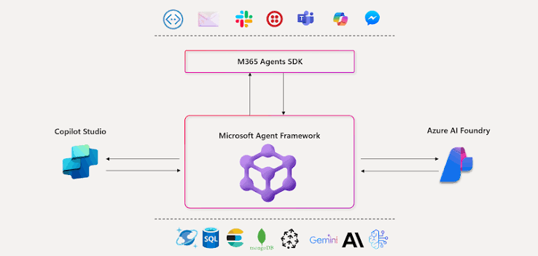
What It Does
- Unifies Past Frameworks: It merges the enterprise-ready foundations of Semantic Kernel (known for production control and reliability) with the multi-agent orchestration and research patterns of AutoGen (known for rapid prototyping and agent collaboration).
- Multi-Language Support: Provides official SDKs and packages for Python, .NET, and Go.
- Workflows & Deterministic Control: Beyond free-form prompting, it features a Workflow API that lets developers design deterministic execution paths (like Directed Acyclic Graphs or DAGs), human-in-the-loop approvals, and state checkpointing.
- Open Standards & Interoperability: Supports standards like the Model Context Protocol (MCP) and Agent-to-Agent (A2A) communication, and integrates smoothly with platforms like Microsoft Foundry, Azure OpenAI, OpenAI, and GitHub Copilot.
- Production Observability: Built with OpenTelemetry support for tracing agent reasoning, data flow, and performance monitoring.

Use Case: AI-Powered E-Commerce Multi-Agent Assistant using Microsoft Agent Framework (MAF)
Imagine building an online shopping assistant like Amazon that uses multiple AI agents to help customers purchase products.
I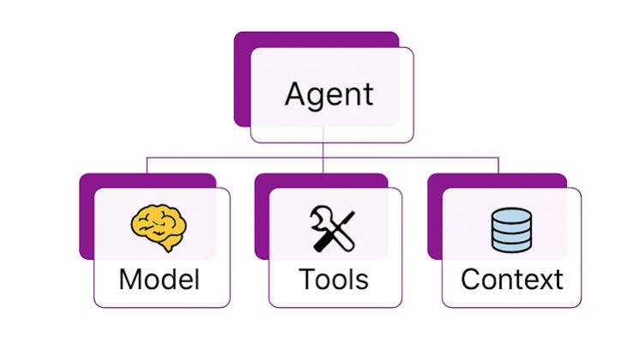

Real-world scenario
A customer asks:
"I need a laptop under ₹60,000 with 16GB RAM. Find the best option, check its availability, and help me place an order."
Instead of one AI agent handling everything, MAF allows you to build multiple specialized agents that collaborate.

Why use MAF here?
Without a multi-agent framework, you might build one large agent responsible for searching products, checking stock, processing payments, and managing orders.
With MAF, you can divide responsibilities among specialized agents and coordinate their execution.
The main advantage: Each agent has a specific responsibility, making the system easier to organize, maintain, and extend.

- What is Microsoft Foundry Agent Service?

Microsoft Foundry Agent Service is a managed cloud service in Microsoft Azure that allows developers to build, deploy, host, and manage AI agents without having to manage all the underlying infrastructure themselves.
- Microsoft Agent Framework (MAF) helps you build AI agents and define how they work together.
- Microsoft Foundry Agent Service provides the cloud environment to deploy, run, and manage those agents.
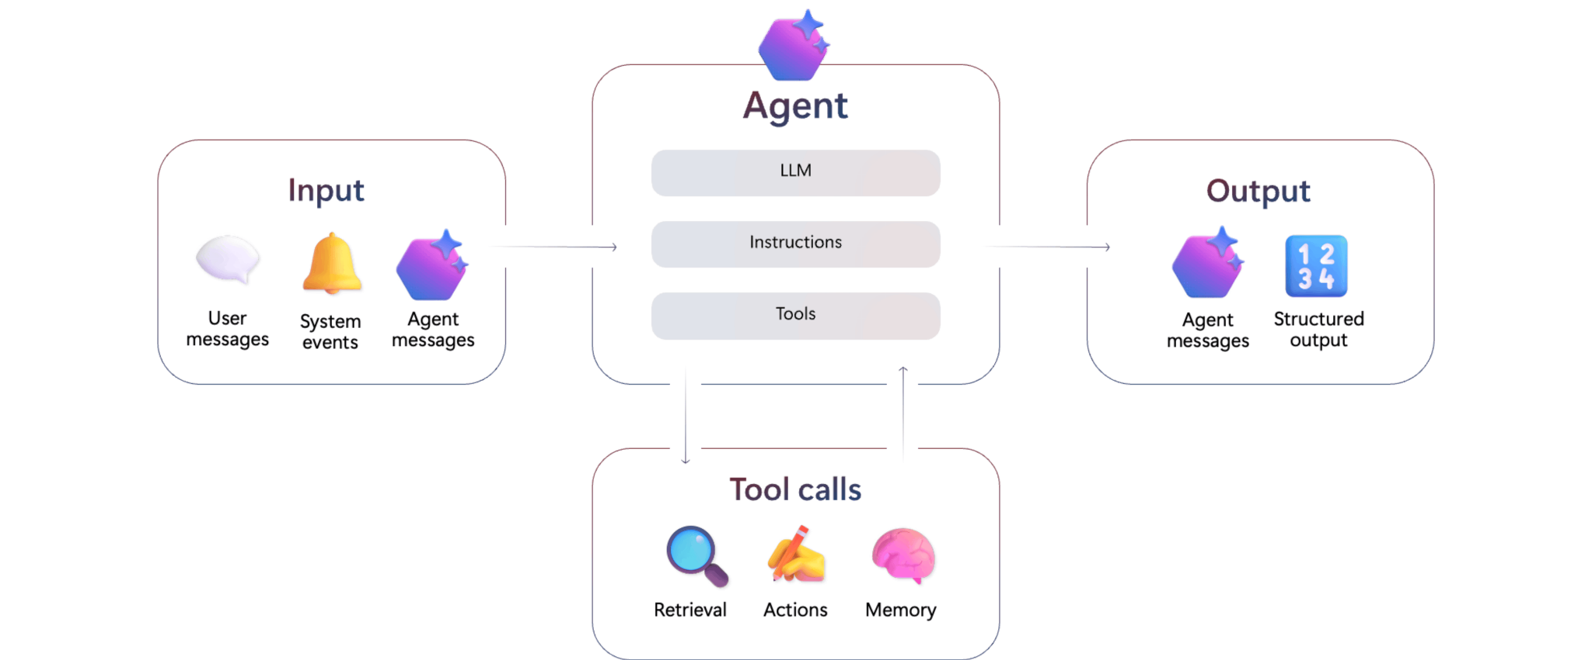
Think of MAF as the development framework and Foundry Agent Service as the hosting and management platform.

1. What does it provide?

Feature | Purpose
Agent hosting | Runs your AI agents in Azure
Agent orchestration | Supports multi-agent workflows
Model integration | Connects agents to supported AI models
Tool integration | Provides web search, file search, code interpreter, MCP and custom tools
Memory | Supports persistent conversation context
Security | Provides authentication, permissions and access control
Monitoring | Tracks agent execution, performance and errors
Scaling | Handles changing workloads
These capabilities are documented by Microsoft.
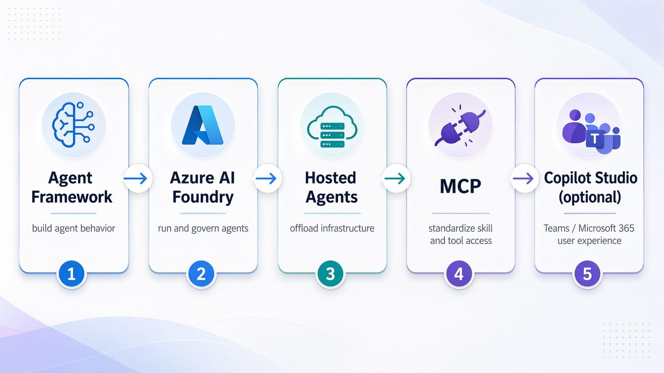
- Write your Python agent code using MAF.
- Define specialized agents and their tools.
- Test the agents locally.
- Deploy the code to Foundry Agent Service.
- Foundry hosts and runs the agents.
- Connect your React or other application to the deployed agent endpoint.

